2018
Student Name

Professor

HEA 341 (01) & (80): Chronic and Communicable Diseases
Fall 2018

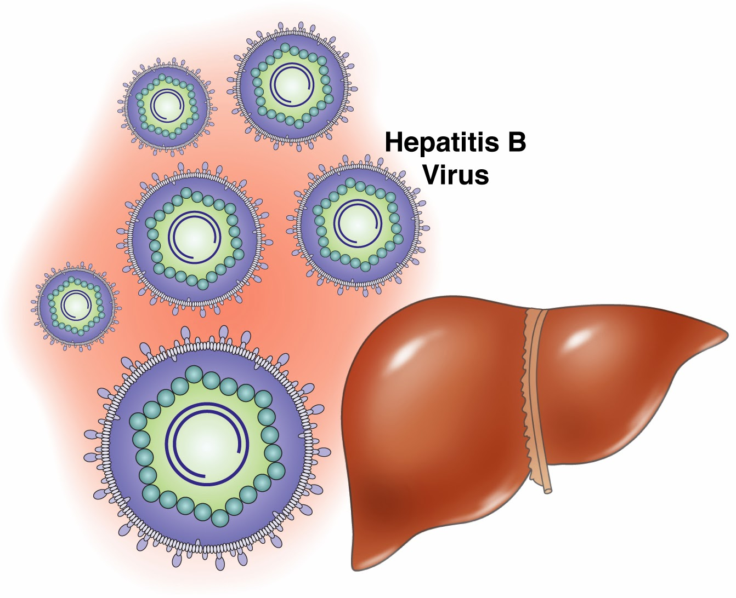

HEpatitis B
Communicable or Chronic Disease Research Report

Hepatitis B
Introduction and Historical Perspective
Hepatitis implies inflammation of the liver. At the point when the liver is inflamed or damaged, it can affect its function. Heavy liquor usage, poisons, some prescriptions, and certain restorative conditions would all be able to cause hepatitis. Importantly, hepatitis is frequently caused by a virus. In the United States, the commonest hepatitis viruses are hepatitis A virus, hepatitis B virus, and hepatitis C virus (CDC, 2018).
It is vital that a reasonable refinement is made between hepatitis A, hepatitis B, and hepatitis C. Hepatitis A, Hepatitis B, and Hepatitis C are liver infections caused by three distinctive viruses. Albeit each can cause comparative manifestations, they are spread in various ways and can influence the liver in an unexpected way. Hepatitis A is generally a transient infection and does not turn into a long term disease. Hepatitis B and hepatitis C can likewise start as short-term infections yet in some people; the virus stays in the body, and causes chronic, or deep rooted, infection. There are immunizations to avoid hepatitis A and hepatitis B; be that as it may, there is no antibody for hepatitis C (CDC, 2018).
Hepatitis B is a liver infection caused by the hepatitis B virus. Hepatitis B can run from a mild ailment enduring half a month to a genuine, deep rooted ailment. Acute hepatitis B is a fleeting ailment that causes inside the initial a half year after somebody is presented to the hepatitis B virus. An acute disease can go in seriousness from a mild ailment with few or no manifestations to a genuine condition requiring hospitalization. Some people, particularly adults, can clear the virus without treatment. Individuals who clear the virus end up resistant and can't get infected with the hepatitis B virus once more. Acute infection can — however does not generally — prompt chronic disease. Chronic hepatitis B is a long lasting infection with the hepatitis B virus. After some time, chronic hepatitis B can cause genuine medical issues, including liver harm, cirrhosis, liver disease, and even death (CDC, 2018).
Historical Perspective
Hepatitis B was considered as an disease in ancient times, yet its etiologic agent was known recently. The primary sign in unwinding this puzzle was the disclosure of a mysterious serum protein named Australia antigen 50 years ago by Baruch Blumberg. Some years after the fact this was known to be the HBV surface antigen (HBsAg). Identification of HBsAg considered the first run through screening of in apparently infected blood contributors for a perilous pathogen. The need to analyze clinically quiet HBV infections was a solid main impetus in the improvement of current virus diagnostics. HBsAg was the primary infection marker to be examined with an exceptionally delicate radio resistant measure. HBV itself was among the main viruses to be recognized by measure of its DNA genome and IgM antibodies against the HBV center antigen were the first to be specifically identified by the anti- μ capture test. The cloning and sequencing of the HBV genome in 1978 prepared to comprehend the viral life cycle, and permitted improvement of productive immunizations and medications. The present hepatitis B immunization was the principal antibody created by quality innovation. Among the issues that still remain today are the failure to accomplish a total fix of incessant HBV infections, the acknowledgment of mysterious HBV infections, their potential reactivation and the fragmented insurance against departure freaks and heterologous HBV genotypes by HBV immunizations (Gerlich, 2013).
Parallel to that, Alfred Prince (New York Blood Center) was particularly searching for a "serum hepatitis (SH) antigen" in the blood of hepatitis B patients and wrote about it in 1968, yet soon he understood that it was indistinguishable to AuAg (Prince, 1968). In this manner, different groups affirmed that Au/SH-Ag was really a marker for acute or chronic hepatitis B and that there were obviously solid Au/SHAg carriers.
Global Epidemiology
Hepatitis B is a noteworthy global medical issue. It can cause chronic disease and puts individuals at high danger of death from cirrhosis and liver cancer. Hepatitis B commonness is most astounding in the WHO Western Pacific Region and the WHO African Region, where 6.2% and 6.1% individually of the adult populace is infected. In the WHO Eastern Mediterranean Region, the WHO South-East Asia Region and the WHO European Region, an expected 3.3%, 2.0% and 1.6%% of the all-inclusive community is infected, individually. 0.7% of the number of inhabitants in the WHO Region of the Americas is infected (WHO, 2018).
The prevalence of Hepatitis B and the age at which disease causes changes drastically between various globally. There is a high predominance (8 15%) in South East Asia, Africa, the Pacific islands, and the Amazon Basin and pockets of the Middle East and North and South America; the commonness is for the most part low (under 2%) in western populaces (Oakes, 2014).
HBV cause 650,000 deaths yearly because of viral hepatitis– initiated liver disease. The overall yearly occurrence of acute HCV disease isn't effortlessly evaluated, on the grounds that patients are regularly asymptomatic. An expected 71 million individuals are chronically infected with HCV around the world (Samji, 2017).
The wide range in the prevelance of patients with chronic HBV in various parts of the world is to a great extent identified with contrasts in the age at infection, which is conversely identified with the danger of chronicity (Figure 1 and Figure 2). The rate of movement from acute to unending HBV infection is roughly 90 per cent for perinatally obtained infection, 20 to 50 per cent for infections between the age of one and five years, and under 5 per cent for adult acquired infection (Wasley et al, 2008).
Epidemiology in the United States
In the United States, an expected 850,000 - 2.2 million people are chronically infected with the hepatitis B virus (See Table 1 and Table 2). New instances of HBV infection in the United States had been diminishing up to this point. In 2013, there were an expected 19,800 acute instances of HBV infection. That is an increase of over 5% contrasted with 2012. This is the first run through in over 20 years that acute HBV cases expanded. This expansion in new HBV infections is an exceptionally concerning pattern which the Centers for Disease Control and Prevention has decided is connected to the continuous narcotic maltreatment pandemic in the United States (Harris et al, 2016).
Harris et al (2016) have noticed that the same numbers of 2.2 million people in the United States are chronically infected with hepatitis B virus (HBV), and around 15%– 25% of people with incessant HBV infection will pass on rashly from cirrhosis or liver cancer. Since 2006, the general U.S. occurrence of acute HBV infection has stayed stable; the rate in 2013 was 1.0 case for every 100,000 people. Hepatitis B immunization is profoundly successful in anticipating HBV infection and is suggested for all new-born children. Hepatitis B inoculation inclusion is low among adults: 2013 National Health Interview Survey information demonstrated that inclusion with ≥3 dosages of hepatitis B immunization was 32.6% for adults matured 19– 49 years.
Among young adults in some rural U.S. towns, an increased occurrence of HCV infection has been related with a simultaneous increment of infusion tranquilize use; and late information demonstrate an expansion of acute HCV disease in the Appalachian locale related with infusion drug use. Utilizing information from the National Notifiable Diseases Surveillance System (NNDSS) amid 2006– 2013, CDC evaluated the frequency of acute HBV infection in three of the four Appalachian states (Tennessee, Kentucky, and West Virginia) incorporated into the HCV infection consider. Like the expansion of HCV infections as of late revealed, an increment in occurrence instances of acute HBV infection in these three states has happened among non-Hispanic (whites) matured 30– 39 years who detailed infusion medicate use as a typical hazard factor. Since 2009, instances of acute HBV infection have been accounted for from more non-urban than urban locales. Proof based administrations to forestall HBV infections are required (Zibbel, 2015).
In the U.S., rates of new HBV infection are most elevated among adults ages 30-49 years old, reflecting low hepatitis B inoculation inclusion among adults in danger. The most widely recognized hazard factor among individuals with new HBV infections was infusing drugs, identified with the narcotic abuse epidemic.
The most astounding rates of chronic hepatitis B disease in the United States happen among outside conceived people, particularly individuals conceived in Asia, the Pacific Islands, and Africa. Over portion of cases in the US are among individuals who were conceived outside of the United States (Harris et al, 2016).
Pathophysiology (Etiology and Pathogenesis)
Ways HBV infection differs geographically. Perinatal transmission is the most well-known course in high predominance zones, for example, Asia or Africa, and is regularly clinically asymptomatic. It leads to HBsAg positive, unending HBV infection in most of the cases. Over 95% of acutely infected teenagers and adults resolve the disease suddenly and don't create incessant hepatitis B.
In chronic HBV infection, three particular stages impacted by the immune framework can be recognized. HBV isn't specifically cytopathogenic. Hepatocellular damage is primarily interceded by the host's safe reaction to viral antigens on the surface of the infected hepatocytes. In acute, self-restricting hepatitis B, solid T cell reactions to HBV antigens are perceivable. In chronic bearers, virus particular T cell reactions in the fringe blood are reduced. Immune response reactions are solid in the two settings (See Figure 3).
Loss of immunological control in immunosuppressed patients can prompt reactivation of HBV DNA replication and hepatitis. Treatment choices incorporate treatments to animate the safe framework, for example, IFN-α, and antiviral treatment as nucleoside/nucleotide turn around transcriptase inhibitors of the HBV polymerase. The recent endorsement of strong antiviral medications, serum HBV DNA decrease regularly leading to enhanced clinical results can be accomplished in most of the cases (Wursthorn, 2010).
The pathogenetic and antiviral capability of the cytotoxic T lymphocyte (CTL) reaction to HBV has been demonstrated by the enlistment of a serious necroinflammatory liver ailment following the supportive exchange of HBsAg particular CTL into HBV transgenic mice. Astoundingly, the CTLs additionally cleanse HBV replicative intermediates from the liver by discharging compose 1 provocative cytokines in this way restricting virus spread to uninfected cells and diminishing the level of immunopathology required to end the infection.
Persistent HBV infection is described by a weak adaptive immune reaction, thought to be because of inefficient CD4+ T cell preparing right off the bat in the disease and consequent improvement of a quantitatively and subjectively inadequate CD8+ T cell reaction. Different elements that could add to viral steadiness are immunological resistance, mutational epitope inactivation, T cell receptor threat, and inadequate down-direction of viral replication and infection of immunologically advantaged tissues. Be that as it may, these pathways wind up evident just in the setting of an inadequate invulnerable reaction which is, in this way, the crucial fundamental reason. Persistent infection is described by unending liver cell damage, recovery, inflammation, across the board DNA harm, and insertional deregulation of cell development control qualities which, by and large, prompt cirrhosis of the liver and hepatocellular carcinoma (Wursthorn, 2010).
Clinical Manifestation (Signs and Symptoms)
It has been noticed that itchy skin has been a sign as a conceivable manifestation of all hepatitis virus composes. The disease goes on for fourteen days and afterward continuously enhances in most affected individuals. A couple of patients may have more extreme liver ailment and may bite the dust because of it. The infection might be completely asymptomatic and may go unrecognized. Not every person who is infected with HBV will encounter manifestations of acute Hepatitis; somewhere in the range of 30 and 40 per cent of individuals infected with the virus don't encounter any perceptible side effects. If chance that side effects do happen, they normally do as such inside four to about a month and a half in the wake of being infected and can last somewhere in the range of fourteen days to a while.
The manifestations of acute hepatitis B can include: yellowing of the skin, dark urine pale stool whites of the eyes, and under the fingernails, joint pain, exhaustion, fever, loss of appetite, abdominal pain, diarrhoea, and nausea (WHO, 2018).
If chance that the resistant framework can't control acute HBV infection inside a half year, manifestations of chronic hepatitis B are conceivable. Not every person with chronic hepatitis B encounters manifestations. Some people with chronic hepatitis B encounter incidental manifestations, while others encounter side effects that never appear to leave.
Chronic infection with hepatitis B virus might be either asymptomatic or might be related with an chronic irritation of the liver (chronic hepatitis), prompting cirrhosis over a time of quite a while. This sort of infection significantly expands the occurrence of hepatocellular carcinoma (liver cancer). Chronic carriers are urged to abstain from devouring liquor as it expands their hazard for cirrhosis and liver disease.
About 30%-half of individual’s age 5 years and more seasoned have indications from acute hepatitis B. Most kids less than 5 years of age and individuals with genuine medical issues, for example, being immunosuppressed, by and large don't have manifestations (CDC, 2018).
Most people with chronic hepatitis B don't have any manifestations, don't feel sick, and can remain indication free for a considerable length of time. Whenever and if indications do show up, they are like the manifestations of acute infection, however can be an indication of cutting edge liver disease. Around 1 of every 4 individuals who turn out to be chronically infected amid adolescence and about 15% of the individuals who turn out to be incessantly infected after youth will in the long amazing genuine liver conditions, for example, cirrhosis or liver cancer. Indeed, even as the liver ends up ailing, some people still don't have side effects, albeit certain blood tests for liver capacity may start to demonstrate some variations from the norm (CDC, 2018).
Diagnosis
It is not conceivable, on clinical grounds, to separate hepatitis B from hepatitis caused by other viral agents and, subsequently, laboratory affirmation of the analysis is fundamental. Various blood tests are accessible to determine and screen individuals to have hepatitis B. They can be used to recognize acute and chronic infections.
Laboratory determination of hepatitis B infection focuses around the identification of the hepatitis B surface antigen HBsAg. WHO suggests that all blood gifts be tried for hepatitis B to guarantee blood security and evade unplanned transmission to individuals who get blood items (WHO, 2018).
Acute HBV infection is described by the presence of HBsAg and immunoglobulin M (IgM) antibody to the core antigen, HBcAg (Diagram 1). Amid the underlying period of infection, patients are likewise seropositive for hepatitis B e antigen (HBeAg). HBeAg is normally a marker of large amounts of replication of the virus. The presence of HBeAg shows that the blood and body liquids of the infected individual are profoundly infectious (Otto et al, 2012).
Chronic disease is described by the persistence of HBsAg for no less than a half year (with or without simultaneous HBeAg). Diligence of HBsAg is the primary marker of hazard for creating incessant liver ailment and liver disease (hepatocellular carcinoma) further down the road (WHO, 2018).
Globally, most astounding HBeAg prevelance of over 50 % was found in 0– 9 years old young ladies. At regenerative age, HBeAg prevalence was 20-50 %. Commonness was most astounding in young females in East Asia in 1990 (78 %), the disease was less regular in Sub-Saharan and North Africa (Otto et al, 2012).
Treatment
There is no medicine accessible to treat acute hepatitis B. Amid this short-term infection, doctors for the most part suggest rest, sufficient food, and liquids, albeit some people may should be hospitalized. Subsequently, care is gone for keeping up solace and sufficient nutrition balance, including substitution of liquids lost from regurgitating and the runs (WHO, 2018).
Treatment varies. Individuals with chronic hepatitis B should look for the consideration or counsel of a specialist with experience treating hepatitis B. This can incorporate some internists or family prescription experts, and in addition masters, for example, infectious malady doctors, gastroenterologists, or hepatologists. Individuals with chronic hepatitis B ought to be observed frequently for indications of liver sickness and assessed for conceivable treatment. Some meds have been affirmed for hepatitis B treatment, and new medications are being developed (CDC, 2018).
WHO prescribes the utilization of oral medicines - tenofovir or entecavir, in light of the fact that these are the strongest medications to stifle hepatitis B virus. They once in a while prompt medication obstruction as contrasted and different medications, are easy to take (1 pill daily), and have few symptoms so require just restricted checking.
Among many people, the treatment does not fix hepatitis B disease, but rather just smothers the replication of the virus. Hence, the vast majority who begin hepatitis B treatment must proceed with it forever. There is as yet restricted access to finding and treatment of hepatitis B in numerous resource strained settings. In 2015, of the 257 million individuals living with HBV infection, 9% (22 million) knew their analysis. Of those analysed, the global treatment inclusion was just 8% (1.7 million). Numerous individuals are diagnosed when they already have advanced liver virus (WHO, 2018).
Prognosis
Hepatitis B is transmitted when blood, semen, or another body liquid from a man infected with the Hepatitis B virus enters the group of somebody who isn't infected. This can occur through sexual contact; sharing needles, syringes, or other medication infusion hardware; or from mother to infant during childbirth. Around the world, the vast majority with Hepatitis B were infected with the virus as a baby. Hepatitis B isn't spread through breastfeeding, sharing eating utensils, embracing, kissing, clasping hands, hacking, or sniffling. In contrast to some types of hepatitis, Hepatitis B is likewise not spread by contaminated water or food water (CDC, 2016).
For some people, hepatitis B is an acute, or short-term, sickness yet for other people, it can turn into a long term, chronic infection. Risk of chronic infection is identified with age at disease: roughly 90% of infected newborn children turn out to be chronically infected, contrasted and 2%– 6% of adults. Chronic Hepatitis B can prompt genuine medical problems, similar to cirrhosis or liver disease (CDC, 2015).
Chronic HBV infection for the most part comprises of an early replicative stage with dynamic liver virus (hepatitis B e antigen [HBeAg]-positive incessant hepatitis) and a late low or non-replicative stage with HBeAg seroconversion and reduction of liver sickness (latent bearer state). After HBeAg seroconversion, some patients may have dynamic hepatitis because of HBV variations not showing (HBeAg-negative chronic hepatitis). Impairment and mortality are connected to advancement of cirrhosis and hepatocellular carcinoma. Survival is sensibly great (about 85% likelihood at 5 years) in remunerated cirrhosis yet extremely poor in decompensated cirrhosis. Both cirrhotic and noncirrhotic patients with supported decrease of HBV replication and standardization of aminotransferase after interferon alfa treatment have a lessened hazard for liver-related entanglements (Fattovich, 2003).
In any case, in around 1 of every 20 affected adults, the disease is chronic and remains in the body for a half year or more. This chronic type of hepatitis B is extremely regular in young newborn children and youngsters (Maureen, 2013). About 90% of babies who are infected as infants and 20% of young kids affected proceed to create chronic infection. Regardless of whether these youngsters don't have indications, they can even now pass the infection onto other individuals (Popalis et al, 2013). Up to 90% of newborn children infected with the Hepatitis B virus will build up an chronic disease. Conversely, about 5% of adults will create chronic Hepatitis B (CDC, 2016).
Among the long term effects of HBV infections, cirrhosis and hepatocellular carcinoma cause a substantial disease trouble. Liver cancer advances quickly, and since treatment choices are restricted, the result is poor. In low-income settings, majority patients with liver disease die after diagnosis. In high-income nations, medical procedure and chemotherapy can drag out life for up to a couple of years. Liver transplantation is some of the time used in individuals with cirrhosis in high salary nations, with shifting achievement (WHO, 2018).
Cirrhosis of the liver can take up to 20 years to develop and may not cause any indications at first. In the end, the liver damage can prompt indications, for example, loss of appetite, weakness, itchy skin, jaundice, pain in the right upper abdomen, among others. Around 10% of people with liver cirrhosis proceed to develop liver cancer. The side effects of liver disease incorporate weight reduction, loss of appetite, queasiness and regurgitating, and jaundice (WHO, 2018).
Conclusion
Hepatitis B virus causes to acute and chronic liver disease in kids and young people around the world. Infection in the childhood is related with decompensated liver virus, expanded morbility and mortality related with cirrhosis and hepatocellular carcinoma in the old age. Hepatitis B virus is transmitted by parenteral contact with infected blood or body liquids (percutaneous), sexual contact, transmission from the infected mother to the infant and close contact with infected individuals which does exclude sexuality
HBeAg presence in childbearing-age women is a noteworthy determinant of perinatal hepatitis B virus (HBV) transmission. The danger of developing chronic HBV infection and liver disease is most astounding at young age. Perinatal HBV transmission is a noteworthy determinant of HBV transmissiomn and its chronic sequelae, and keeps up HBV transmission over generations. HBeAg commonness gauges gave from this examination are an imperative segment for surveying the HBV-related malady weight and its temperate and restorative results. Furthermore, HBeAg epidemiology is of significance as access to treatment for incessant HBV infection is extended with expanding treatment choices in asset restricted settings
Summarily, HBV acts like a stealth virus early in infection, staying undetected and spreading until the beginning of the adaptive immune reaction a little while later. The general intangibility of HBV to the natural detecting apparatus of the cells most likely mirrors its replication methodology with the repeating viral genome being shielded inside viral capsid particles in the cytoplasm. Also, HBV can be controlled when properly initiated HBV-specific CD8+ T cells enter the liver, recognize antigen, kill infected cells, and emit IFNγ which triggers a wide based course that intensifies the fiery procedure and has noncytopathic antiviral movement against HBV. Inability to trigger early CD4+ T cell reactions, as causes in low portion infections, leads to practically impeded CD8+ T cell reactions bringing about the foundation of persistent disease.

References
Blumberg B. (2002). Hepatitis B - The Hunt for a Killer Virus. Princeton: Princeton University Press
CDC. (2015). Hepatitis B Information for Professionals. Center for Disease Control. Retrieved from: https://www.cdc.gov/hepatitis/HBV/index.htm
CDC. (2015b). Hepatitis B: General Information. Center for Disease Control. Retrieved from: https://www.cdc.gov/hepatitis/hbv/pdfs/hepbgeneralfactsheet.pdf
CDC. (2018). Hepatitis B Questions and Answers for the Public. Center for Disease Control and Prevention. Retrieved from: https://www.cdc.gov/hepatitis/hbv/bfaq.htm
CDC. (2018b). Hepatitis B. Statistics and Surveillance. Retrieved from: https://www.cdc.gov/hepatitis/statistics/index.htm
Fattovich, G. (2003). Natural history and prognosis of hepatitis B. Seminar on Liver Disease. DOI:10.1055/s-2003-37590
Gerlich, W. (2013). Medical Virology of Hepatitis B: how it began and where we are now. Virology Journal. Retrieved from: https://virologyj.biomedcentral.com/articles/10.1186/1743-422X-10-239
Harris, M, Iqbal K,… Schillie S. (2016). Increases in Acute Hepatitis B Virus Infections — Kentucky, Tennessee, and West Virginia, 2006–2013. MMWR Morb Mortal Wkly Rep;65:47–50. DOI: http://dx.doi.org/10.15585/mmwr.mm6503a2
Maureen M. (2013). Hepatitis B Virus Infection in children. CLD. 2:41–4.
Oakes K (2014) Chronic hepatitis B, part 1: Hepatitis B: Prevalence and Pathophysiology. Nursing Times; 110: 7, 12-16. Retrieved from: https://www.nursingtimes.net/clinical-archive/infection-control/hepatitis-b-prevalence-and-pathophysiology/5067776.article
Ott,j., Stevens, A, & Wiersman ,A. (2012). The Risk of Perinatal Hepatitis B Virus Transmission: Hepatitis B (hbeag) Prevelance Estimates for All World Regions. BMC infect Dis.;12:131. Retrieved from: http://dx.doi.org/10.1186/1471-2334-12-131
Popalis, C, Yeung. F, Ling S, & Roberts E. (2013). Chronic Hepatitis B Virus (HBV) Infection in Children: 25 Years Experience. Journal of Viral Hepatitis. 20:20–6. http://dx.doi.org/10.1111/jvh.12019
Prince A. (1968). Relation of Australia and SH Antigens. Lancet. 2 (7565): 462-463
Samji, N. (2017). Viral Hepatitis. Medscape. Retrieved from: https://emedicine.medscape.com/article/775507-overview
Wasley A, Grytdal S, Gallagher K. (2008). Centers for Disease Control and Prevention (CDC). Surveillance for acute viral hepatitis--United States, 2006. MMWR Surveill Summ; 57:1.
WHO. (2018). Hepatitis B. World Health Organization. Retrieved from: http://www.who.int/news-room/fact-sheets/detail/hepatitis-b
Wursthorn, K. (2010). hronic Hepatitis B: Pathophysiology, Diagnosis and Treatment Options. Basel, Karger.
Zibbell J, Iqbal K, …Patel R. (2015).Increases in Hepatitis C virus Infection Related To Injection Drug Use Among Persons Aged ≤30 years—Kentucky, Tennessee, Virginia, and West Virginia, 2006–2012. MMWR Morb Mortal Wkly Rep ;64:453–8.

Appendices

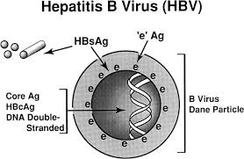

Diagram 1: HBV Structure


Table 1: Hepatitis Prevelance in the US. (CDC, 2018b)
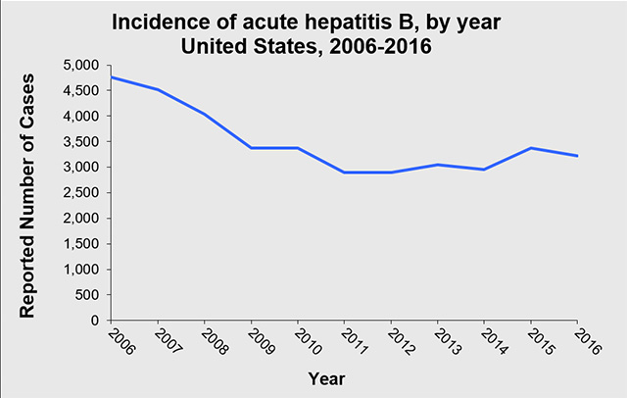
Table 2: Acute Hepatitis B in the USA (CDC, 2018b)
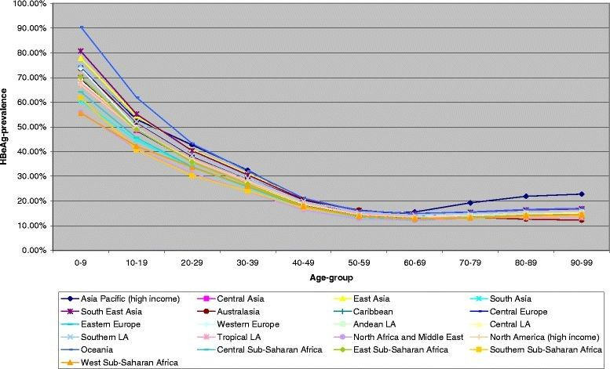
Figure 1: HBeAg among HBsAg-positive females, 1990.

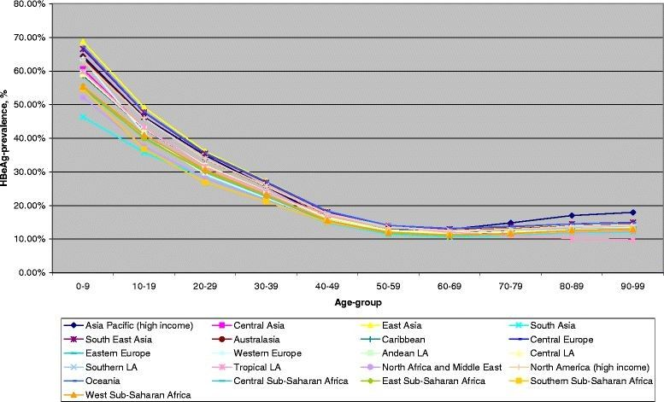
Figure 2
HBeAg among HBsAg-positive females, 2005.

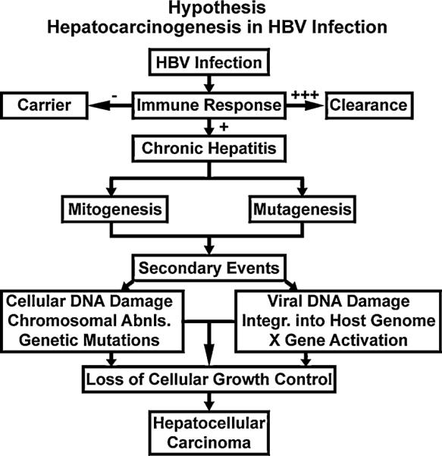

Figure 3: The chronic injury → HCC hypothesis. From this hypothesis, a (+++) immune response to HBV leads to viral clearance and an absent (−) immune response causes the “healthy” carrier state, and an intermediate (+) immune response produces chronic hepatitis. The collaboration of mitogenic and mutagenic stimuli can cause cellular and viral DNA damage, chromosomal abnormalities, genetic mutations, etc, which deregulates cellular growth control in a multistep process leading to hepatocellular carcinoma. (Source: Am J Pathol 2000, 156:1117–1132).

